**OUR STAFF**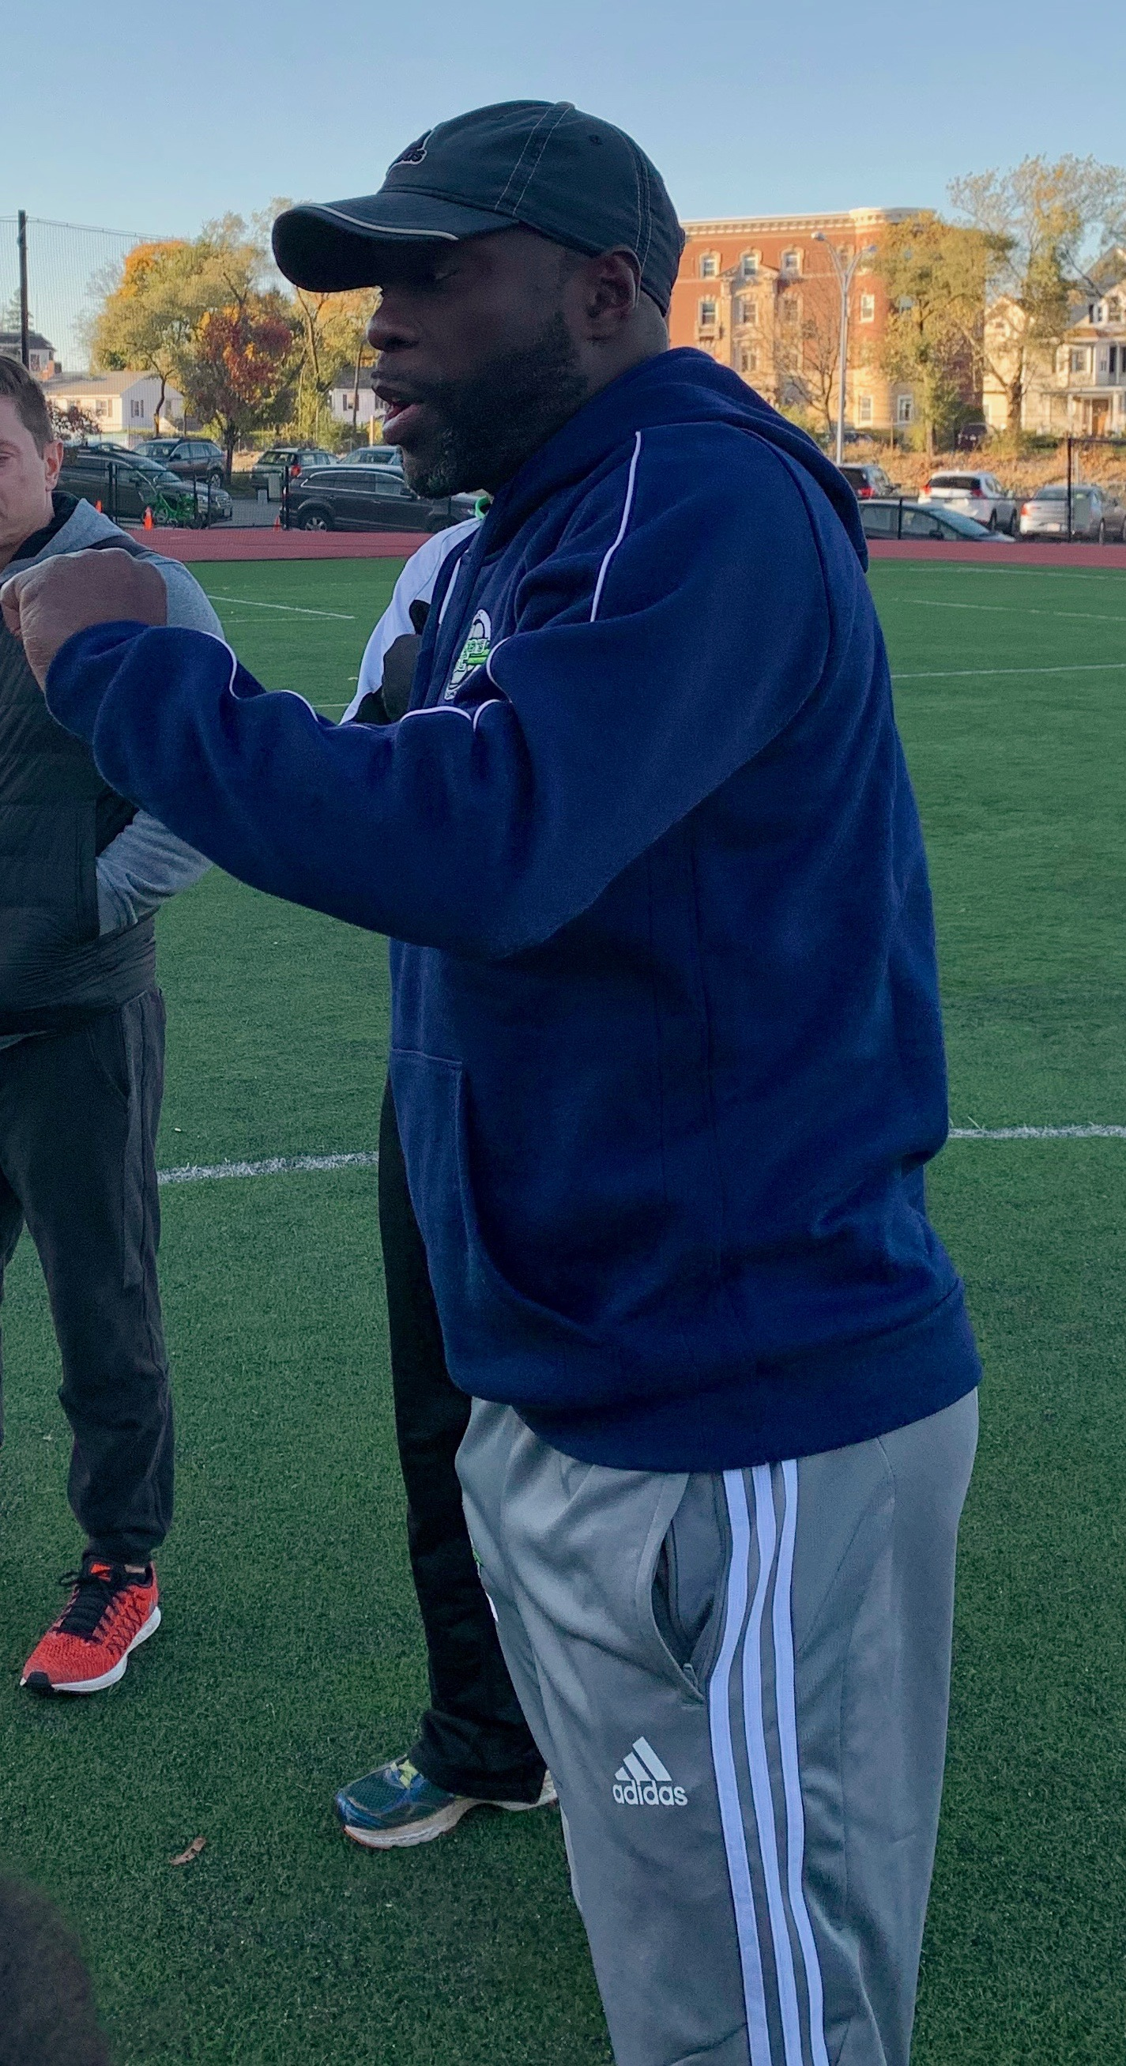

JAMES BEDE

Soccer is not what he does it is who he is.

He has developed a unique program to develop players into top level players.

He has sent players to Division 1 and overses

Club and Camp Staff

All our staff members are either currently playing the game or they have been playing at a high level.

All members of JBSC have to go thru the JBSC way of coaching.